ASSIGNMENT 12

1) To convert a string to uppercase

//To convert a string to uppercase
#include<iostream.h>
#include<conio.h>
#include<stdio.h>
#include<ctype.h>
main()
{
clrscr();
char str[20];
cout<<"Enter a string ";
gets(str);
for(int i=0;str[i]!='\0';i++)
str[i]=toupper(str[i]);
cout<<str;

getch();
}
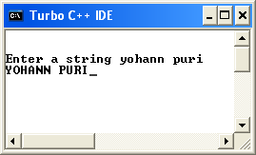
2) To check if it is an alphabet and to check its case

//To check if it is an alphabet and to check its case
#include<iostream.h>
#include<conio.h>
#include<stdio.h>
#include<ctype.h>
main()
{
clrscr();
char ch;
cout<<"Enter a character ";
cin>>ch;
if(isalpha(ch))
{
cout<<"It is an alphabet"<<endl;
if(isupper(ch))
cout<<"It is an uppercase character";
else
cout<<"It is a lowercase character";
}
else
cout<<"It is not an alphabet";
getch();
}
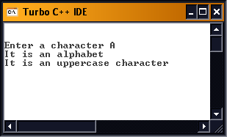
3) To concatenate three strings

//To concatenate three strings
#include<iostream.h>
#include<conio.h>
#include<stdio.h>
#include<string.h>
main()
{
clrscr();
char first[20],middle[20],last[20],full[60]="";
cout<<"Enter first name ";
gets(first);
cout<<"Enter middle name ";
gets(middle);
cout<<"Enter Last Name ";
gets(last);

strcat(full,first);
strcat(full," ");
strcat(full,middle);
strcat(full," ");
strcat(full,last);

cout<<"Full name is "<<full;
getch();
}
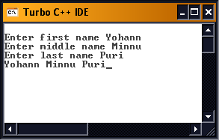
4) To fetch a password and check if its correct

//To fetch a password and check if it’s correct
#include<iostream.h>
#include<conio.h>
#include<stdio.h>
#include<string.h>
main()
{
clrscr();
char enter[10],pass[10]="yohann";
cout<<"Enter password ";
for(int i=0;i<=10;i++)
{
enter[i]=getch();
if(enter[i]=='\r')
break;
cout<<'*';
}
int j=strcmp(pass,enter);
if(j==0)
cout<<endl<<"OK!";
else
cout<<endl<<"SORRY!";
getch();
}
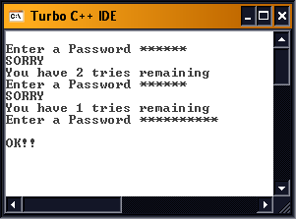
5) Copy One string into another

//Copy One string into another
#include<iostream.h>
#include<conio.h>
#include<stdio.h>
#include<string.h>
main()
{
clrscr();
char str1[10],str2[10];
cout<<"Enter first string ";
gets(str1);
cout<<"Enter second string ";
gets(str2);
int i=strlen(str1),j=strlen(str2);

if(i>j)
{
strcpy(str1,str2);
cout<<str1;
}
else
{
strcpy(str2,str1);
cout<<str2;
}

getch();



